**Parking problem**

The idea of this project is to park a car using a Reinforcement Learning algorithm. During the path for the parking there might be some obstacles that must be avoided by the car. Furthermore, the parking must be done with a short path.

A first approach to solve it would be to simulate the environment with a matrix with zeros and ones to distinguish forbidden and allowed zones. The car will have an arbitrary initial position and also the parking will have an arbitrary position. The car must proceed then toward the parking avoiding forbidden zones. There also some constrainst about the movements that the car can do. It can only go forward and backward and to steer, it cannot move horizontally. In this simplified model it’s assumed that the car can steer also at rest.

So the algorithm at each step will get the current position of the car and gives as output the direction of motion (backward,forward or motionless) and it’s orientation. The loss function is the distance travelled by the car.

At the beginning the algorithm has no knowledge about the forbidden and allowed zones so it will need to explore the environment and learning iteration by iteration how to achieve the goal.

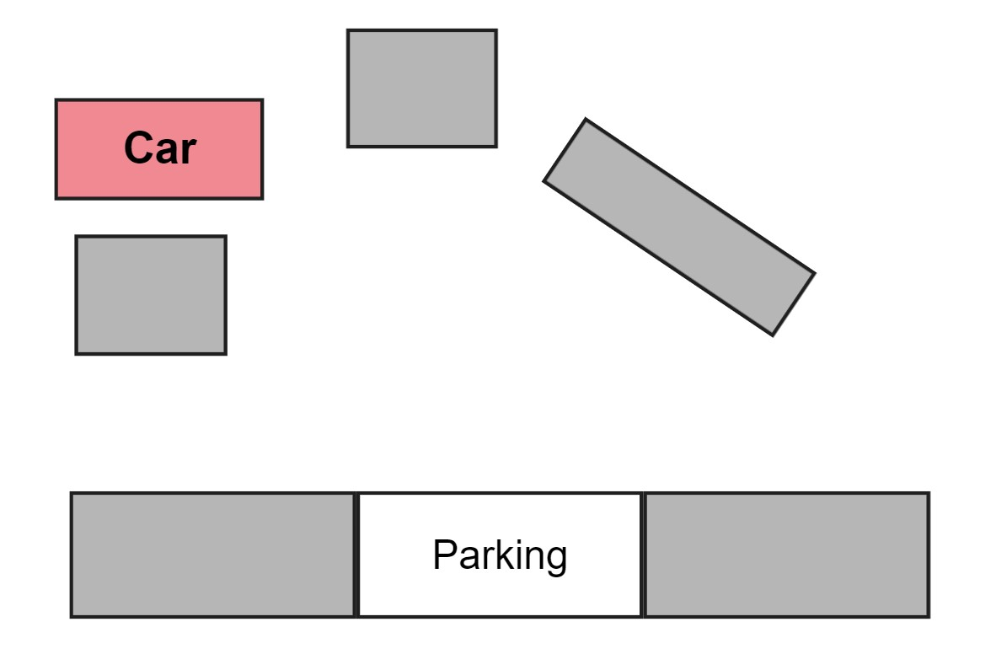

**.(x,y)**

θ

This problem could be solved with different approaches, e.g. with an optimal control approach, but the advantage with RL is that it would be possible to hande different situation with arbitrary positions of the obstacles. Analitically this would be difficult to the hight number of constraints, and that more number of calculations.